**Experiment 6**

**Student Name:** Sahil Kaundal **UID:** 21BCS8197

**Branch:** BE CSE (Lateral Entry) **Section/Group:** 807/B

**Semester:** 4th **Date of Performance:** 05/04/2022

**Subject Name:** MPI Lab **Subject Code:** 22E-20CSP-253

1. **Aim/Overview of the practical:**

* Shift left 8-bit number by 1 bit.
* Program to Shift Left 8-bit Number by 2 Bit

**2. Task to be done/ Which logistics used:**

* Shift left 8-bit number by 1 bit.
* Program to Shift Left 8-bit Number by 2 Bit

**3. Apparatus / Simulator Used:**

1. Jubin Application

2. 8085 Simulator

3. JDK

**4. Algorithms/Flowcharts:**

* Shift left 8-bit number by 1 bit.

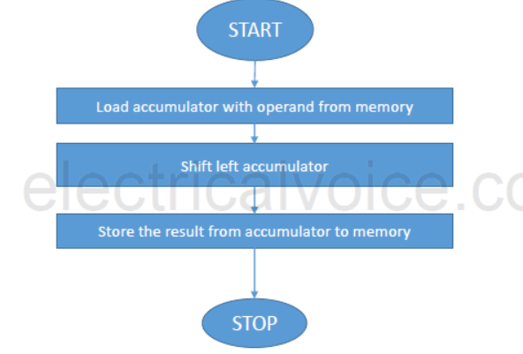

* Program to Shift Left 8-bit Number by 2 Bit

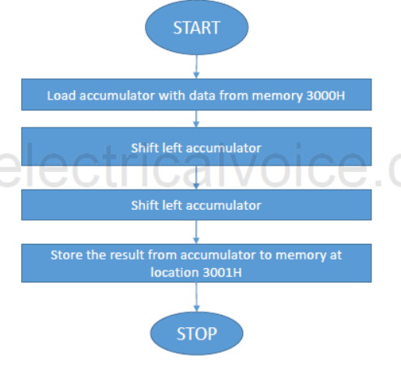

**5. Programs:**

**Shift left 8-bit number by 1 bit.**

# BEGIN 0000H

LDA C050

ADD A

STA C051

HLT

# ORG C050

# DB 65H

**Program to Shift Left 8-bit Number by 2 Bit**

# BEGIN 0000H

LDA C050

ADD A

ADD A

STA C051

HLT

# ORG C050

# DB 15H

**6. Result/Output/Writing Summary:**

* **Shift left 8-bit number by 1 bit.**

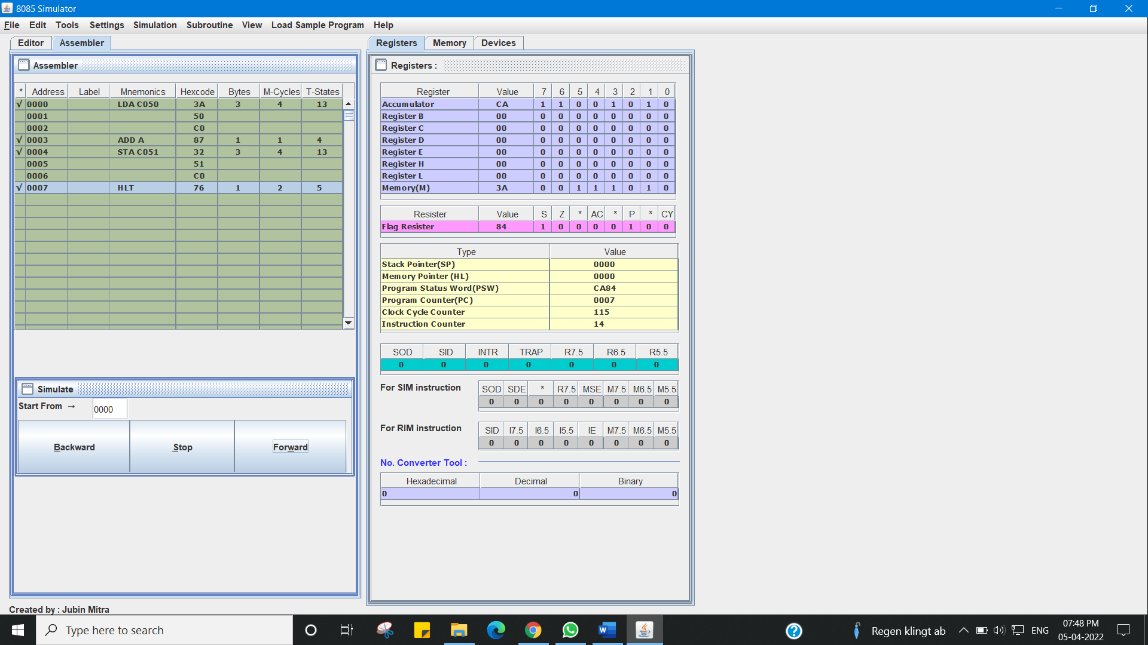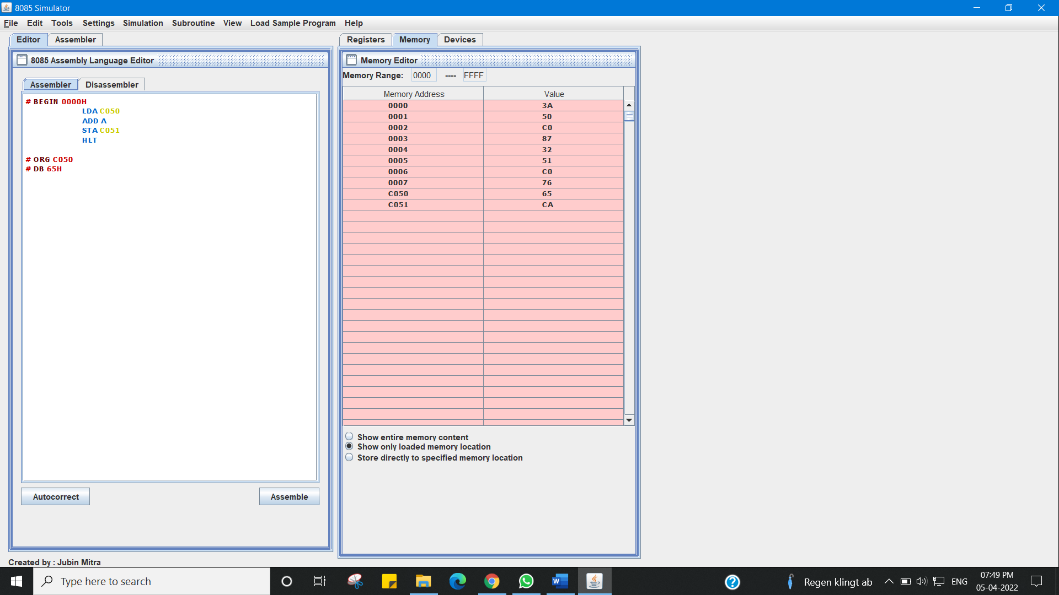

* **Program to Shift Left 8-bit Number by 2 Bit**

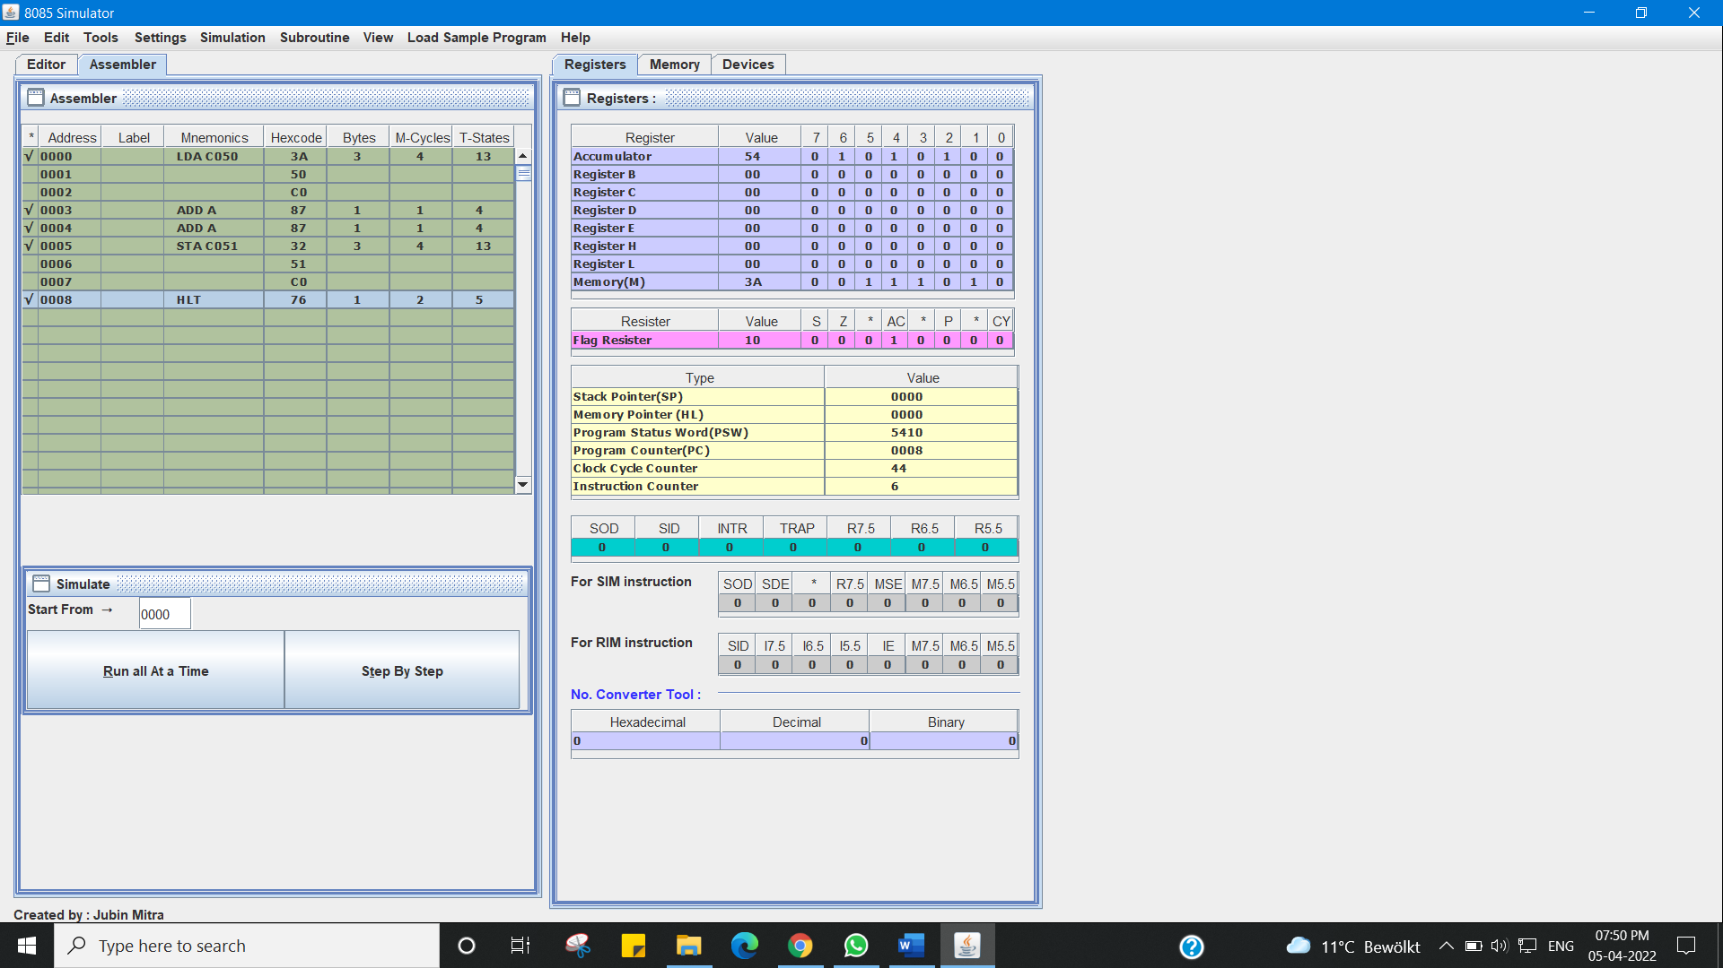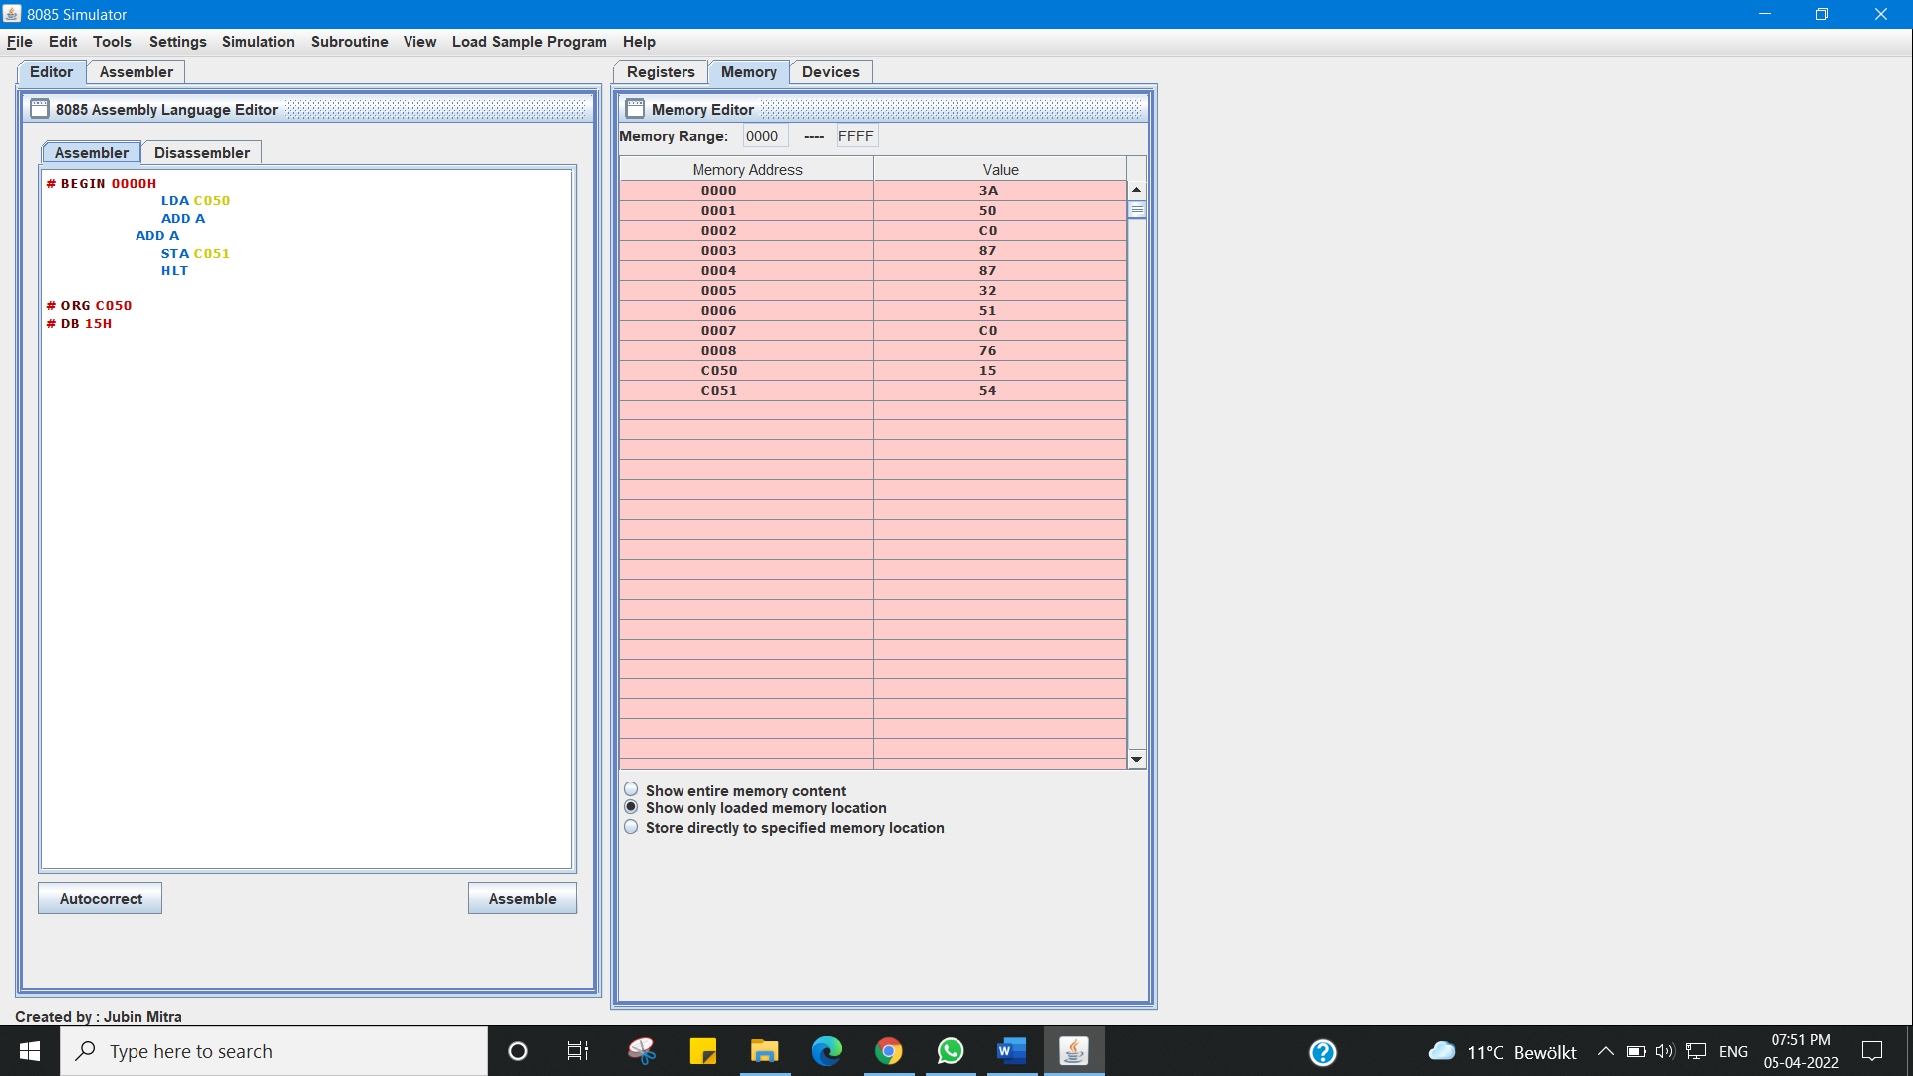

**Learning outcomes (What I have learnt):**

1. Working of microprocessors.

2. Learn how to shift left 8-bit number by 1 bit and Program to Shift Left 8-bit Number by 2 Bit

data in microprocessors.

3. Learn about 8085 simulator.

4. Operations of 8 bit numbers.

5. Learn about the different instructions that are needed to be given to the memory to perform some tasks.

**Evaluation Grid (To be created as per the SOP and Assessment guidelines by the faculty):**

|  |  |  |  |
| --- | --- | --- | --- |
| Sr. No. | Parameters | Marks Obtained | Maximum Marks |
| 1. |  |  |  |
| 2. |  |  |  |
| 3. |  |  |  |
|  |  |  |  |